NSHE Mentoring Institute 2026 (MI2026):
Creating Connected Mentoring Communities to Support Student Success and Research Excellence:
Scaling Mentorship for Research Growth and Institutional Capacity Building Across NSHE

DAY 1: October 7, 2026

9.15 What Does Student Success Look Like? Mentorship, Inclusion, and Impact
How do we define student success—and who gets to shape that definition? This interactive session invites participants to reflect on the role of mentorship in supporting diverse student outcomes. Together, we will explore the qualities of impactful mentoring and discuss ways to cultivate research spaces that are inclusive, supportive, and empowering for all students.

How would you (or your campus) define Student Success? (think pair share)

- 2 minutes write on your own
- 3 minutes share with a partner
- 3 minutes compare at your table
- Report out table theme

Knowing that only some factors are potentially impactful from the institutional perspective, how does mentoring support student success? Who and What

[To be considered later] How do the characteristics of mentoring, and the desired outcomes of mentoring, show up in research settings?

[[To be considered later] How would you and your campus define research excellence? How are student success and research excellence interconnected (via mentoring)?

References:

The science of mentorship in STEMM (2019) National Academies

PANEL – Achieving Student Success: From Participation to Implementation: Insights from MI2025 Returners
This session features MI 2025 returners sharing their journeys from intention to implementation. Panelists will reflect on the goals they set during the previous year, discuss successes achieved, and openly address barriers encountered along the way. The session will also generate forward-looking ideas to sustain momentum and deepen impact, with opportunities for audience engagement and shared problem-solving.

Program, Institution, challenge/goal | Action | Impact on student success

11.10-Noon Achieving Success Working Groups: Identifying needs by roles
Role based small groups - students, faculty, administrators- to identify needs.
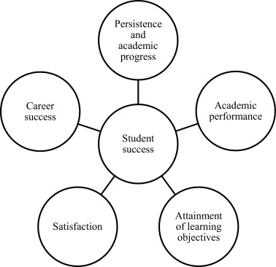
- What are the greatest needs at your institution from your perspective?
- What are the assets that you bring to a mentorship relationship?

- LARGE GROUP DISCUSSION

LUNCH: Noon-1pm

1.15-2pm Understanding Institutional Frameworks: Elevating existing programs and practices
This interactive session is designed to foster meaningful connections across roles, institutions, and disciplines in alignment with the Mentoring Institute’s commitment to strengthening mentorship and collaborative practice. Through structured networking and guided “speed collaboration” rounds, participants will engage in focused conversations that surface shared interests, challenges, and opportunities for partnership. The session emphasizes inclusive engagement, encouraging participants to learn from diverse perspectives while identifying pathways to support student success through mentoring and collaborative efforts.

In what areas or through what programs is your institution effectively mentoring students and faculty for success? Think about structures, resources

What gaps or challenges remain to achieving student success and research excellence on your campus?

What threats exist to sustaining successful programs and services on your campus?

2-3pm Collaborative Connections: Building capacity within the NSHE network
intentional strategic planning across institutions to ensure success. Sustain practices by moving beyond the walls of an institution. Groups mixed for institution and role

With research excellence as the goal, how do you create the conditions/approaches to address identified needs and meet that goal across the system?

How opportunities exist for leveraging collective resources and assets across the system to “lift all ships” by addressing the needs and gaps identified today?

3-315 Break

3.15-345: Sharing insights
What is one thing that you learned from another campus that you would replicate or adapt for your campus?

What is one topic that remains a shared concern or opportunity for improvement?

What is one way you can leverage the NSHE network to improve mentoring structures for student success and research excellence?

345-445: (Re)imagining mentoring for student success in research excellence
After everything discussed today, How would you (re)imagine Mentoring for Student Success in Research Excellence?

- 3 minutes write on your own
- 4 minutes share with a partner
- 5 minutes compare at your table

Report out table theme(s)

NSHE Mentoring Institute 2026 (MI2026):
Creating Connected Mentoring Communities to Support Student Success and Research Excellence:
Scaling Mentorship for Research Growth and Institutional Capacity Building Across NSHE

Day 2: October 8, 2026

830-930 am: Council on Undergraduate Research- Elevating Research, Empowering Community, Driving Excellence and Innovation

How are your ideas for Mentoring for Student Success in Research Excellence reflected in the COEUR?
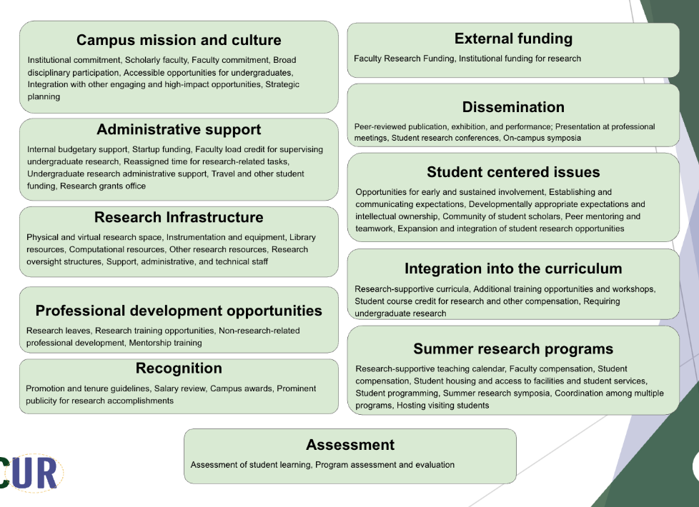

2 minutes write on your own
4 minutes share with a partner
5 minutes share at your table

930- 10am Achieving Excellence: Guided Case Study
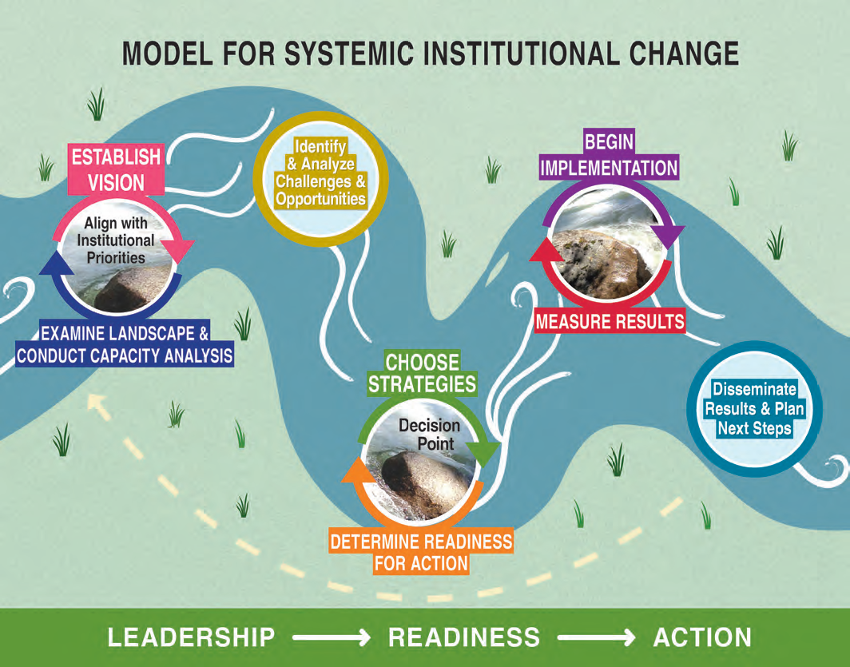
Program level/Department Level
College/Division/University Level

Vision
Landscape and capacity analysis
Challenges and Opps
Choose strategies
Readiness for action
Implement
Measure results

Case study discussion: Pick one article from the PEER REVIEW PDF- Navigating Institutional change
Prompts: Comment on Vision, Capacity/Resources, Strategies, Results,
Reporting OUT; What is ONE idea that comes out of your table discussions

10.15-11am: Goal setting and Planning: Institutional teams
This session is time to work within institutional teams for establishing priorities based on everything learned and discussed so far.
How do we achieve excellence as we meet our needs for student success?

11-11.45 Building networks within NSHE
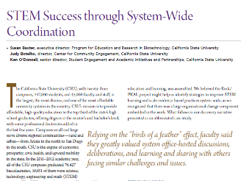
“Ask not what NSHE can do for you- ask what you can do for NSHE”
How do we think beyond the institution and leverage NSHE as a network for collaborative achievements?

How can the institutions support NSHE to support the institutions?
What are your greatest needs where collaborative problem solving could benefit your work?

1145- Noon The Final Bite: Reflections, Evaluations, and Continued Dialogue

